NATIONAL UNIVERSITY OF COMPUTER AND EMERGING SCIENCES

CS 103 - COMPUTER PROGRAMMING LAB
Instructor: Ms Farah Sadia
farah.sadia@nu.edu.pk

LAB SESSION # 01

Outline
- Introduction to Object Oriented Programming
- Why Object Oriented Programming is used?

- Difference between C and C++
- Explanation of basic C++ program
- Common Escape Sequence
- Data types in C++

- Operators in C++ (arithmetic operators, relational operators, logical operators, increment and decrement operators, assignment statement)

- Decision Statement in C++ (if statement, if else statement, nested if statement, else if statement, switch statement)

- Iterative Statements in C++ (the for loop, the while loop and the do-while loop)
- Exercise

INTRODUCTION TO OBJECT ORIENTED PROGRAMMING

- Object Oriented Programming (OOP) is a programming concept used in several modern programming languages, like C++, Java and Python.

- Object Oriented Programming works on the principle that objects are the most important part of a program. Manipulating these objects to get results is the goal of Object Oriented Programming.

- In OOP, the data is grouped together with the methods that operate upon it, which makes it easy to maintain the integrity of the data and provide a structure to the program.

Question: So what is an object oriented program exactly?

Answer: It is a program that contains objects, of course, which have certain properties and have methods linked to them. These methods are used to obtain a programming result.

WHY IS OOP NEEDED?

Problems with Procedural Languages

- Functions have unrestricted access to global data
- Unrelated Functions and data.

Before Object Oriented Programming programs were viewed as procedures that accepted data and produced an output.
There was little emphasis given on the data that went into those programs.

1

DIFFERENCE BETWEEN C AND C++

The key differences include:

C | C++
It is a structural or procedural programming language. | It is an object oriented programming language.
Emphasis is on procedure or steps to solve a problem | Emphasis is on objects rather than procedure
Functions are the fundamental building blocks. | Objects are the fundamental building blocks.
In C, the data is not secured. | Data is hidden and can’t be accessed by external functions.
C uses scanf() and printf() functions for standard input and | C uses cin>> and cout<< functions for standard input and
output. | output.
In C, namespace feature is absent. | In C++, namespace feature is present.
C program file is saved with .C extension. | C++ program file is saved with .CPP extension.

Table 1: Difference between C and C++

EXPLANATION OF BASIC C++ PROGRAM

An Example C++ Program

/* Comments can also be written starting with a slash followed by a star, and ending with a star followed by a slash. As you can see, comments written in this way can span more than one line. */ /* Programs should ALWAYS include plenty of comments! */ /* This program prints the table of entered number */

#include <iostream>
using namespace std;
int main()
{
int input_num;

//the number whose
cout<<"Enter number";
cin>>input_num;
for (int i=0;i<=10;i++)
{

int output = input_num*i;
cout<<input_num<<"*"<<i<<"="<<output<<endl;
}
return 0;
}

Program Output if 3 is entered as input to input_num

2

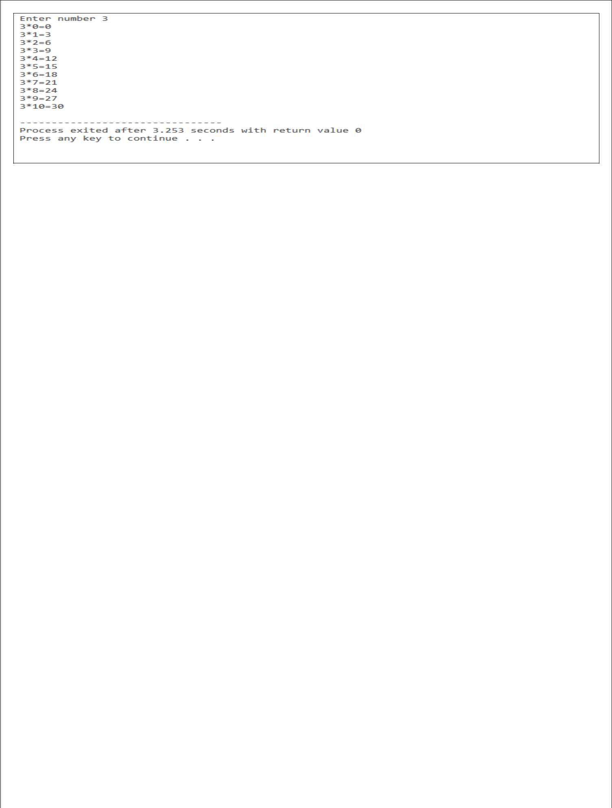

- The #include Directive

The #include directive causes the contents of another file to be inserted into the program Preprocessor directives are not C++ statements and do not require semicolons at the end

- Using namespace std;

The names cout and endl belong to the std namespace. They can be referenced via fully qualified name std::cout and std::endl, or simply as cout and endl with a "using namespace std;" statement.

- return 0;

The return value of 0 indicates normal termination; while non-zero (typically 1) indicates abnormal termination. C++ compiler will automatically insert a "return 0;" at the end of the the main () function, thus, it statement can be omitted.

- Output using cout

- Cout is an object
- Corresponds to standard output stream
- << is called insertion or input operator

- Input With cin

- Cin is an object
- Corresponds to standard input stream
- >> ισ χαλλεδ εξτραχτιον ορ γετ φρομ οπερατορ
Character |  | Name |  | Description
// | double slash |  |  | Marks the beginning of a comment
# | Pound sign |  |  | Marks the beginning of a preprocessor directive
< > | Opening and closing brackets |  |  | Encloses a filename when used with the #include directive
( ) | Opening | and | closing | Used in naming a function, as in int main ()
 | parenthesis
{ } | Opening and closing braces |  |  | Encloses a group of statements, such as the contents of a
 |  |  |  | function.
" " | Opening and closing quotation |  |  | Encloses a string of characters, such as a message that is to be
 | marks |  |  | printed on the screen
; | Semicolon |  |  | Marks the end of a complete programming statement
 |  | Table 2: Mandatory symbols in basic program

3

COMMON ESCAPE SEQUENCES

Escape Sequence | Name |  | Description
\n | Newline |  | Causes the cursor to go to the next line for subsequent printing
\t | Horizontal tab |  | Causes the cursor to skip over to the next tab stop
\b | Backspace |  | Causes the cursor to back up, or move left one position
\r | Return |  | Causes the cursor to go to the beginning of the current line, not
 |  |  | the next line
\\ | Backslash |  | Causes a backslash to be printed
\' | Single quote |  | Causes a single quotation mark to be printed
\" | Double quote |  | Causes a double quotation mark to be printed
 |  | Table 3: Escape Sequence

DATATYPES

There are many different types of data.

Variables are classified according to their data type, which determines the kind of information that may be stored in them.
Integer variables only hold whole numbers.

Data Type | Size |  | Range
short | 2 bytes |  | -32,768 to +32.767
unsigned short | 2 bytes |  | 0 to +65,535
int | 4 bytes |  | -2,147,4833,648 to +2,147,4833,647
unsigned int | 4 bytes |  | 0 to 4,294,967,295
long | 4 bytes |  | -2,147,4833,648 to +2,147,4833,647
Unsigned long | 4 bytes |  | 0 to 4,294,967,295
 |  | Table 4: Data types and size

Other Data Types

- Char Data Type

- Usually 1 byte long
- Internally stored as an integer
- ASCII character set shows integer representation for each character
- ‘A’ == 65, ‘B’ == 66, ‘C’ == 67, etc
- Single quotes denote a character, double quotes denote a string

- Boolean Data Type

Boolean variables are set to either true or false

OPERATORS

There are many operators in C++ for manipulating data which include arithmetic Operators, Relational Operators, Logical operators and many more which will be discussed accordingly.

- Arithmetic Operators

Operator | Description
+ | Addition
- | Subtraction
* | Multiplication

4

/ |  | Division
% |  | Modulo
 | Table 5: Arithmetic Operators
- Relational Operators

Operator |  | Description
= = |  | Equals to
!= |  | Not Equals to
< |  | Less than
> |  | Greater than
<= |  | Less than or equal to
>= |  | Greater than or equal to
 | Table 6: Relational Operators
- Logical Operators

Operator |  | Description
&& |  | Logical AND
| | |  | Logical OR
! |  | NOT
 | Table 7: Logical Operators
- Increment and Decrement Operators

C++ introduces increment and decrement operators which are ++ and – respectively. These operators increment/decrement 1 in the operand’s value.

For example: x++ will be equivalent to x=x+1 or x+=1.

The special characteristic of these operators is that they can be used for pre-increment as well as post-increment. To understand, consider the following statements:

A=b++; //The statement will assign the contents of b to A and then increments the value of b by 1 A=++b; //The statement will first increment the value of b by 1 and then assign the new value to A.

- Assignment statements

value = 5; //This line is an assignment statement

The assignment statement evaluates the expression on the right of the equal sign then stores it into the variable named on the left of the equal sign. The data type of the variable was in integer, so the data type of the expression on the right should evaluate to an integer as well.

DECISIONS

Sometimes, we want a program to choose among several possible alternative courses of action.
This means that some statements in the program may not be executed.
The choice between alternatives is based on some condition

A condition is either true or false
Use relational and/or logical operators to express a condition

Following are the main types of decision statements:

5

Statement | Description
If statement | An if statement consists of a boolean expression followed by one or more statement
If… else statement | An if statement can be followed by an optional else statement, which executes when the
 | boolean expression is false
nested if statements | You can use one if or else if statement inside another if or else if statement(s)
Switch statement | A switch statement allows a variable to be tested for equality against a list of values
Nested Switch statement | You can use one swicth statement inside another switch statement(s)

if statement

- Single statement if condition

if (expression)

statement;

Statement will be executed only if expression is true

Sample Program

#include <iostream>

using namespace std;
int main()
{
int x;
cin >> x;
if (x == 5)

cout <<"Condition is true and the value of x is "<<x; return 0;
}

Program Output is 5 is entered as input to x

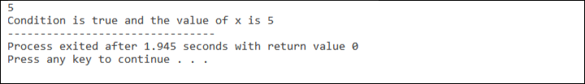

Program output if other than 5 is entered as input to x

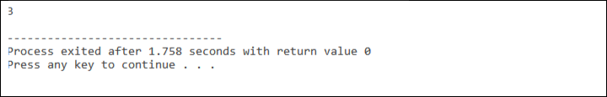

- Compound statement if condition

Often, we want to execute several statements if a condition is true. Use braces to indicate the block of statements to be executed.

6

if (expression)

{
statement1;

statement2;
}

Sample Program

#include <iostream>
using namespace std;
int main()
{
int x;

cin >> x;
if (x == 5)
{
cout <<"Condition is true and the value of x is "<<x;

cout <<"\nWelcome to NUCES-FAST";
}

return 0;
}

Program Output is 5 is entered as input to x

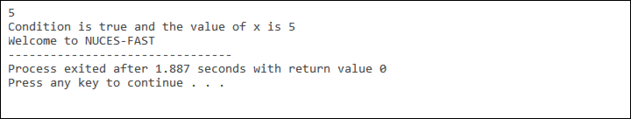

if else statement

if (expression)

statement1;
else
statement2;

Statement1 will be executed if expression is true Statement 2 will be executed if expression is false. Both statements will never be executed.

Sample Program

#include <iostream>
using namespace std;
int main()
{
int x;

cin >> x;
if (x == 5)

7

{

cout <<"Condition is true and the value of x is "<<x;
}
else

{
cout <<"Condition is false.";
}
return 0;
}

Program Output is 5 is entered as input to x

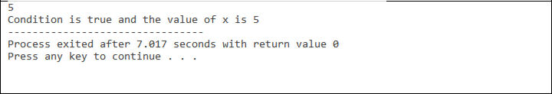

Program output if other than 5 is entered as input to x

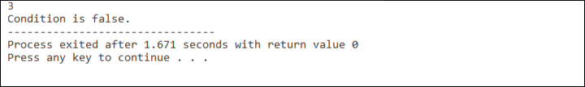

Nested if statement

Possible to put one if or if-else statement inside another if or if-else statement

if (expression1)
{
statement1;
if (expression2)
{
statement2;
}

}

Sample Program

#include <iostream>
using namespace std;
int main()

{
int age;
cout<<"Enter your age: ";
cin >> age;
char gender;

cout<<"\nEnter your gender i.e, M for male and F for female: ";
cin >> gender;

if (age < 4)

8

{

if(gender=='M')
cout <<"\nA baby boy";

else
cout <<"\nA baby girl";
}
return 0;
}

Program output if age is less than 4 and gender is male

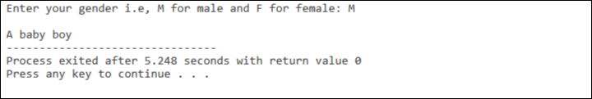

Else if statement

if (expression1)

statement 1;

else if (expression 2)

statement 2;
...
else

statement n;

Sample Program

#include <iostream>
using namespace std;
int main()

{
int percentage;
cin >> percentage;
if (percentage >= 50)
cout << "You have passed";

else if (percentage < 50)
cout << "Try your best to clear the course in next attempt."
return 0;

}

Program output if percentage is greater than or equals to 50

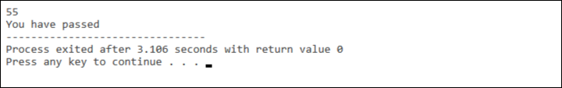

Multiple conditions can be written by making several else-is clauses. Once a condition is true, control will never go to other

9

else-if conditions. You can also add an else clause after else if statements.

ITERATIVE STATEMENTS (LOOPS)

Loops repeat a statement a certain number of times, or while a condition is fulfilled. They are introduced by the keywords while, do, and for.

- The for loop

The for loop is designed to iterate a number of times.

Its syntax is:

for (initialization; condition; increase)
statement;

Sample Program

#include <iostream>
using namespace std;
int main()
{
for (int n=10; n>0; n--)
{
cout << n << ", ";
}
cout << "\nEnd of for loop\n";

}

Program output

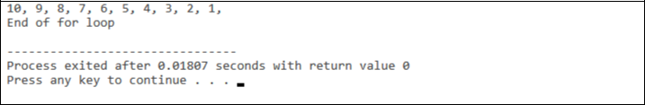

- The while loop

The simplest kind of loop is the while-loop.

Its syntax is:

while (expression
statement;

The while-loop simply repeats statement while expression is true. If, after any execution of statement, expression is no longer true, the loop ends, and the program continues right after the loop.

Sample Program

10

#include <iostream>

using namespace std;
int main()
{

int n = 10;
while (n>0)
{
cout << n << ", ";
--n;

}
cout << "\nEnd of while loop";
}

Program output

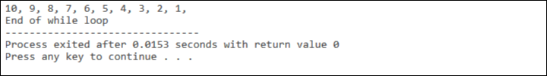

- The do-while loop

A very similar loop is the do-while loop, whose syntax is:

do

statement;

while (condition);

It behaves like a while-loop, except that condition is evaluated after the execution of statement instead of before, guaranteeing at least one execution of statement, even if condition is never fulfilled.

Sample Program

#include <iostream>

#include <string>
using namespace std;
int main ()

{
string str;
do
{
cout << "Enter text: ";
getline (cin,str);
cout << "You entered: " << str << '\n';

}
while (str != "goodbye");
}

Program Output

11

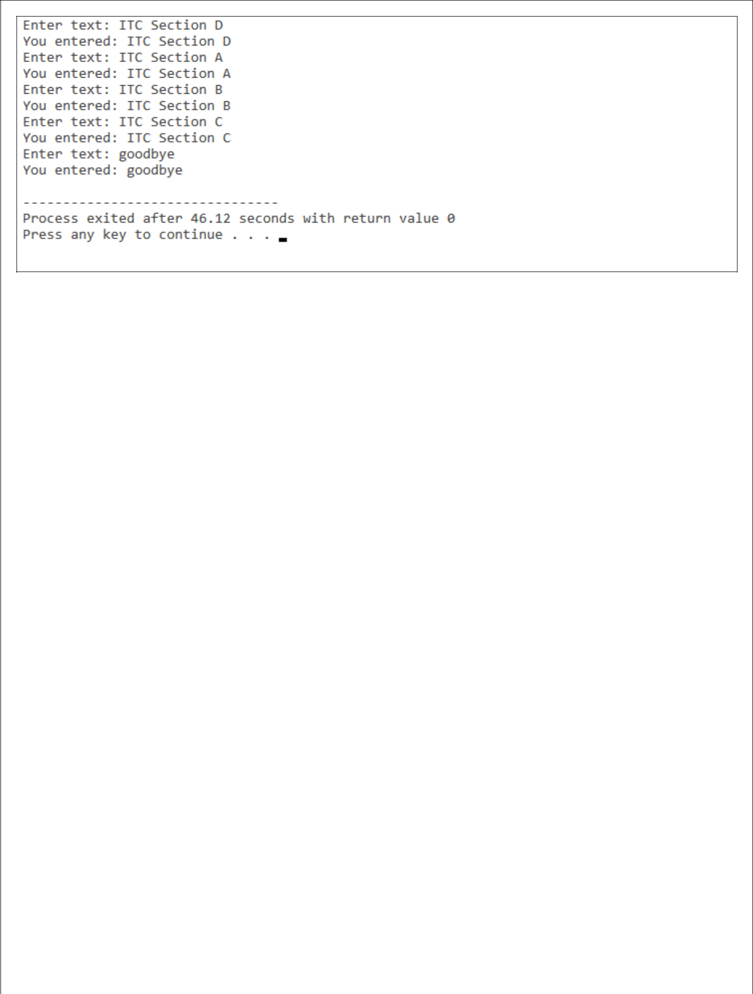

12

